Specific Conditions

Indicator 1.1

Tranche | 2ndVariable
Objective I | “Enhance policy development and coordination in the central public administration”
Expected result: | Improved policy planning, coordination capacities and processes in the central public administration
Indicator | Evidence of progress in terms of implementation
Action | Activities related to objectives 2.2\2.5\2.6 of the PAR Roadmap Action Plan
Entity responsible | Administration of Government (AOG) – Policy Analysis Strategic Planning and Coordination Department
Description of the Indicator
Type | Quantitative and qualitative
Measurement unit | Number of policy structural units with policy planning and analysis capabilities and number of strategies aligned with the new policy planning framework.
Periodicity | Annual
Method of Data collection | Administrative Collection (PAR Council reports; pilot ministries reports).
Benchmark 1.1.2:“At least one monitoring report of each selected sectoral strategy is prepared in line with the Handbook for policy planning and is published per each of the five pilot ministries. Each report shows evidence of the degree of progress and/or delays in the implementation of the action plans of sectoral strategies and proposes (where necessary) corrective actions”.
Sources of Verification 1.1: Five monitoring reports (one per each pilot ministry) providing the evidence specified under condition 1.1.2 above.
Level of Achievement: |  | 80% with possibility to increase to 100% (see explanation of proposed scoring section)
- Comment on the structure of the Benchmark in the relevant tranche:
The formulation of Indicator 1 Benchmark 1.1.2 for the 2nd variable tranche is referring to the achievement of both quantitative and qualitative targets. It is expected that the Pilot Ministries that introduced Policy Units in 2016 - as a requirement of Benchmark 1.1.1 - have produced and published in 2017, at least one monitoring report of their respective sectoral strategies. It is also required that these reports are done in accordance with the Policy Planning Handbook.
The above noted, AT paid closer attention to the qualitative element tied to the Benchmark, looking at each strategy of the pilot Ministries and developing a compliance matrix for each monitoring report.
Here below are presented the conclusions of this comparative assessment; while individual matrix templates for each strategy\monitoring report are attached in annex to this report (see Annexes B section).

The Benchmark clearly stipulates that the monitoring reports of five selected sectoral strategies must satisfy several sets of requirements:
- Has the monitoring report of each selected sectoral strategy been prepared in line with the Policy Planning Handbook?
- Has it been published?
- Does each report show the evidence of the degree of progress?
- Does each report show the delays in the implementation of the action plans of sectoral strategies?
- Are there corrective actions proposed (where necessary)?
However, the AT has to underline that the formulation of the Benchmark itself is not completely in line with the Policy Planning Handbook as according to this - the subject of monitoring (assessment) are ‘annual progress reports and not- monitoring reports. Consequently, the reports under review, as a rule, do lack of a more analytical approach (assessment of progress and failures} and are more on the other side more focused on accounts of events and other quantitative information.
- Comments on direct achievement of the Benchmark in the relevant tranche:
  - Quantitative
The subject of assessment are 5 monitoring/progress reports for 5 sectoral strategies:

Name of the report | Timeframe of assessment | Number of strategy objectives for monitoring/assessment
Monitoring report on the implementation of Agriculture Development Strategy Action Plan 2016 | 2016 | 7
Monitoring Report on Strategic Objectives and Action Plan for the Unified Strategy of Education and Science (2017-2021) | 2017 | 15
National Hepatitis C Virus Elimination Progress Report, Georgia 2015-2017 | 2016-2017 | 6
Annual Progress Report (2017) of SME Development Strategy Action Plan 2016-2017 | 2016-2017 | 5
Report on Monitoring of National Anti-Corruption Action Plan of Georgia 2015-2016 | 2015-2016 | 14

Considering the sheer number of the requirements a monitoring report must meet under this Benchmark, it is no surprise that, at this stage, none of the reports reviewed addressed all of them, in particular elaboration of progress and failures against indicators and information pertinent to action plans. Yet, the Report on the Unified Strategy of Education and Science 2017-2021 has almost all the required items accounted for with just information on failures and problems encountered as well as corrective measures and future steps missing. (Annex B-2)

The structure and the content of the Report on the Agriculture Development Strategy diverged from the mandated content under this Benchmark. (See Annex B1) This report is very detailed (174 pages) and presents aggregated data demonstrating achievements without covering the required format from the Handbook. However, this report has all the required content and data according to manual, but in other format and content.

The Progress Report on the Elimination of Hepatitis C Virus Strategy could be generally assessed as satisfactory. Yet the very title of this report gives rise to dilemma whether this is a report on the implementation of an action plan or the Strategy. Despite visible effort invested in, additional work is needed on the standardized form and content in line with the requirements from the Handbook (e.g. there is no explicit mentioning of the action plan being subject of the monitoring, although the report itself refers to the monitoring of the action plan as it arises from the strategic areas being monitored). The character of a progress report requires that all categories mentioned therein to be clearly and unequivocally identified and explained thereby leaving no room for any dilemma on the side of an average reader. (Annex B-3)

The Report on the S.M.E. Development Strategy 2016-2020 could be assessed as generally satisfactory although some sections could be added or improved (executive summary and identification of risks and failures). (Annex B-4)
The Progress Report on Implementation of 2015-2016 National Anti-Corruption Action Plan of Georgia in English translation was delivered with a certain delay (after 1st mission). The Report is almost exclusively limited to chronographic account of the activities implemented without providing qualitative data and information. Generally, it could be assessed as satisfactory. (Annex B-5).

Qualitative
In qualitative terms, the monitoring reports are supposed to provide details of two sets of information:
- The first set is to be applied to the monitoring report as a whole and comprises the following three groups of requirements specified in the Policy Planning Handbook:
  - The qualifying pre-requisite that the monitoring report has been published (only published reports that the professional and lay public have had a chance to scrutinize should be subject of this evaluation).
  - Requirements regarding the process of producing monitoring reports:
    - Drafting of monitoring reports is an annual, or a more frequent activity;
    - The monitoring report is published by the ministry responsible for the development of multisectoral/sectoral strategy or, alternatively, by an interagency council/commission with the function of monitoring the policy implementation;
    - The monitoring report is actually prepared by a dedicated internal unit, or a designated officer (in case of smaller ministries);
    - The leading agency develops and disseminates inquiry forms, and may issue instructions and set deadlines for the purpose of information gathering;
    - The leading agency integrates the gathered information into one analytic text, etc.
  - Mandatory content of each monitoring report, as follows:
    - Executive summary (this part includes brief information on the achievement of each goal based on performance indicators as well as the information on the process of key reforms, and aims at informing the decision makers, public at large and stakeholders)
    - There is a dedicated section for each and every strategic objective, wherein the following is elaborated:
      - Description of progress achieved;
      - Information on activities implemented in that particular year;
      - Information on whether performance indicator targets were achieved;
      - Description of the key reforms implemented;
      - Brief description of risks and problems/failures;
      - Information which may also be included pursuant to Annex 3 of the Policy Planning Handbook, such as:
        - assessment of main achievements based on performance indicators;
        - success stories;
        - assessment of the gaps/challenges;

- The second set explicitly pertains to the sections of the monitoring report that elaborate on the performance of the action plans implementing the sectoral strategies. Thus, each monitoring report must:
    - Show evidence of the degree of progress and/or delays in the implementation of the action plans of sectoral strategies, as well as
    - Propose corrective actions, where necessary.

It was common for most of the reports under this review to focus on listing the activities carried out but omitted to provide qualitative analyse of the impact and progress achieved, particularly against the indicators. Likewise, mentioning of any failure or problem encountered or foreseen and proposing corresponding measures are universally avoided or inadequately elaborated on. If not for these shortcomings, the Report on the Unified Strategy of Education and Science 2017-2021 would be 100% compliant with the Benchmark.
In light of the qualitative requirements above, the particular reports are viewed as follows:

- Monitoring report on the implementation of Agriculture Development Strategy Action Plan 2016
This monitoring report slightly diverges from the Policy Planning Handbook (the executive summary and the assessment of all strategic objectives are rudimentary in comparison to the elements mandated by the Policy Planning Handbook). Although the Report may be significantly improved, it still meets the requirements from this benchmark.
General assessment:
This monitoring report slightly diverges from the Policy Planning Handbook (the executive summary and the assessment of all strategic objectives are rudimentary in comparison to the elements mandated by the Policy Planning Handbook). Although the Report may be improved, it still meets the requirements from this benchmark.
General impression:
The Report is not fully structured in accordance with the Policy Planning Handbook (e.g. weak mandatory executive summary and sections per each strategic objective i.e. direction). There are mainly aggregated data demonstrating achievements with a weak analytical narrative, announcement of future steps and corrective measures. These deficiencies should be rectified in the future reports in order to comply with the Handbook.
However, the justification why the report is not fully structured in accordance with the Handbook could be the fact that the Agriculture Development Strategy Action plan was elaborated and approved more than a year before publishing the Handbook.

- Monitoring Report on Strategic Objectives and Action Plan for the Unified Strategy of Education and Science (2017-2021)
General impression
This monitoring report is very well developed and very comprehensive. Just analytical views on the failures and problems encountered as well as corrective measures and future steps are missing. With these shortcomings rectified this report could serve as a best-practice model against which other monitoring reports could be drafted.

- National Hepatitis C Virus Elimination Progress Report, Georgia 2015-2017
This report covers the time span between mid-2015 up to 2017 which is not completely in line with the requirement from the Handbook. This report is now official document and is available at the following link: http://www.ncdc.ge/Pages/User/Documents.aspx?ID=33a11d14-e71c-4b28-ad39-d6670090664c
General impression
While the report is rather strong and informative in substantive terms, as well as its appendices are eye-catching, which is not subject of this review, it does not meet the formal requirement to cover a time span of a year, or less. The presentation of the indicators is neither easily visible nor existent in all instances and, consequently, the analysis of the progress against the indicators is weak. Likewise, there is no information on any action plan for the implementation of the strategies. As already mentioned above, the form and the content of the future reports should be aligned with the requirements from the Handbook.
.

Annex B3 – Review of the monitoring report re. the elimination of hepatitis c virus strategy
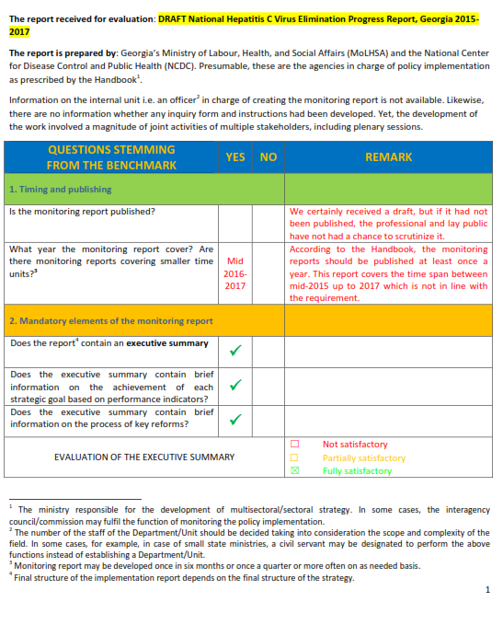

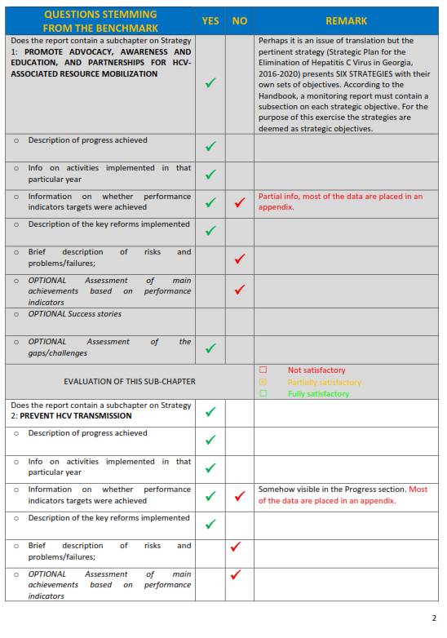

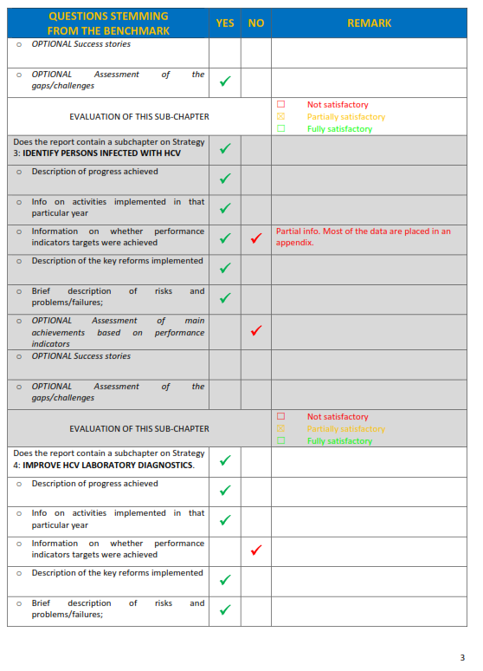

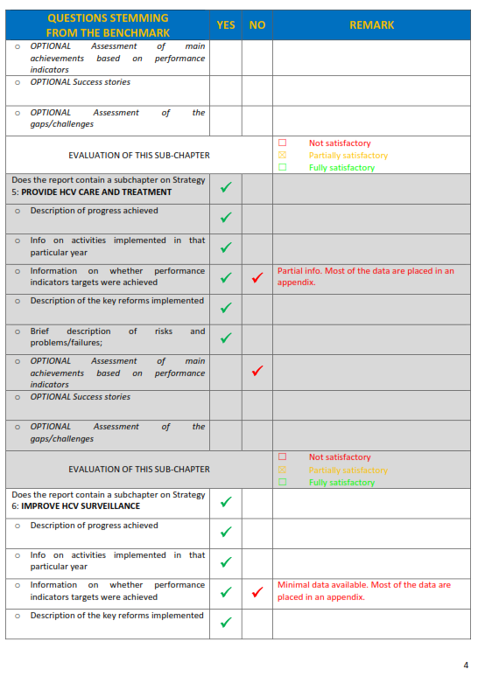

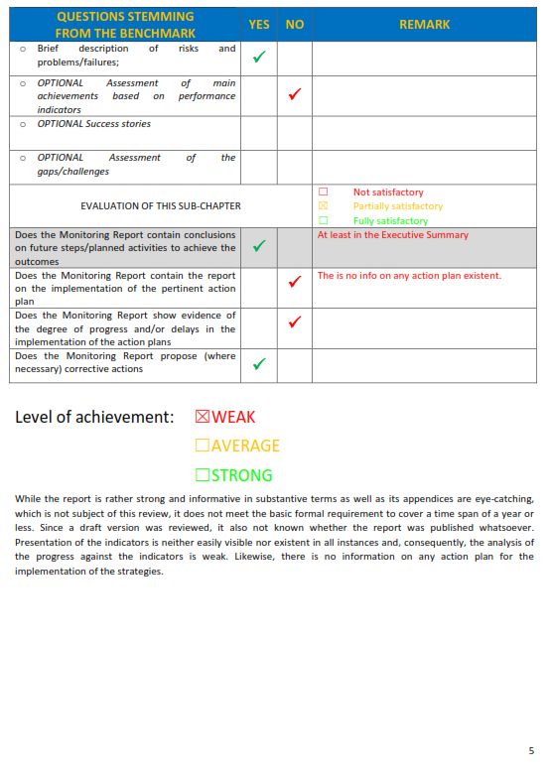

All parties are kindly asked to note that there may an error in Annex 1 under Data for 2017: The text currently reads ‘Assessment in Q2 2018, target: 1.1.2. Published PAR Action-plan 2019-2020 providing the evidence specified under condition 1.1.2 above.’ Perhaps the text should more properly read, ‘Assessment in Q2 2018, target: 1.1.2. One Consolidated Report validated by PAR Council providing the evidence specified under condition 1.1.2 above.’

